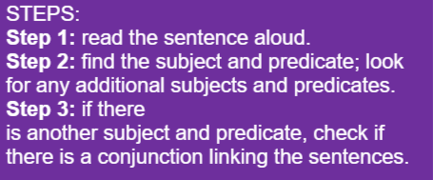

Circle if the sentences below are a run-on sentence or a complete sentence:
Miss G drove to school and she passed two of her friends and she waved at them.
Complete sentence Run-on sentence
Mr B injured his back while playing discus however he still enjoys the sport.
Complete sentence Run-on sentence
During lunch time, Michael briskly walked to the grocery store.
Complete sentence Run-on sentence
I had a sip of my hot tea and it burnt my tongue and then I was really upset.
Complete sentence Run-on sentence
As quick as a flash, Sally made her favourite hot chocolate.
Complete sentence Run-on sentence
Extension: Explain why your sentences are either complete or run-on sentences. Follow the steps by circling the conjunction IF there is one.

